User Requirements Document

Discussion Paper

Chartered Institute of Building

VAT Partial Exemption Plug-In

Version 1.1

Prepared by :
Charles Craven-Bartle
TSG Ltd
Kulite House
Stroudley Road
Basingstoke

RG24 8UG

CIOB VE 1-1 URD.doc
Updated 15th August 2005

Project Overview

Document
This is the User Requirements Document covering the software development work, requested by the Chartered Institute of Building, to provide a VAT Partial Exemption Plug-In for the Exchequer Enterprise system.

Required Functionality
The Exchequer Enterprise Purchase and Nominal transaction entry programs are to be modified to automatically calculate the allowed & disallowed portions of partially exempt VAT transaction lines. The VAT value against the expense line is to be recalculated based on the allowed percentage and the disallowed value of VAT is to be posted, as a separate transaction line, against the expense nominal code of the original entry. The original transaction values are to be stored in user defined fields within the transaction.
The percentage of chargeable VAT that is to be applied to partially exempt transactions will be based on a percentage constant set at the start of each quarter.

Software Development
The VAT Partial Exemption system is to be developed using the Borland Delphi programming language and will reference the Exchequer DLL Toolkit objects.
The software is to be developed to run on Microsoft XP Standard, XP Professional & Windows 2000 operating systems. The target PC’s should have the latest Microsoft Windows Updates applied.

**** NOTE ****

NM 25/5/2005

Screenshots in this document show an example of a POR. This Plug-in does not work with POR’s
Screenshots in this document show an example of a NOM. This Plug-in does not work with NOM’s

The only transaction types that this plug-in will work with are PIN’s and PCR’s.

Exchequer Configuration

To provide the functionality required, a bespoke Exchequer Plug-In is to be developed that will be activated as Purchase and Nominal transactions are saved by the user.
The VAT Partial Exemption Plug-in will reference VAT codes that are set against each Supply (Stock) Code and a Percentage Constant that determines the allowed / disallowed portion of VAT.

Supply Codes
Every expense item going through the CIOB Purchase Ledger is allocated a Supply Code. The Supply Code, which is entered as the Stock Code against the Purchase Ledger transaction line, is the same as the GL Nominal Code assigned to that expense item.
A block of Stock Codes within the Exchequer Stock system will be used to maintain the list of Supply Codes. Each Supply Code will be a Description-Only type Stock Item and will have the Stock Code number set to the same number as the Nominal GL Code for the expense item. For example, Nominal Code 10198, ‘Temp Salaries’, will have a corresponding description-only stock record 10198, ‘Temp Salaries’.

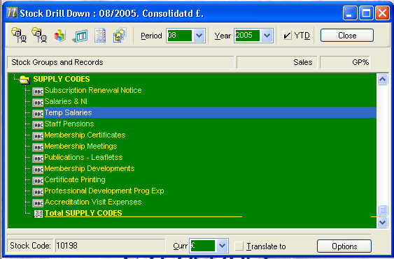

This structure allows a default VAT Code to be assigned to each Supply Code so that each Nominal Code is linked to a default VAT Code :
S - Standard Rate
E – Exempt
1 – Partially Exempt
Z –Zero

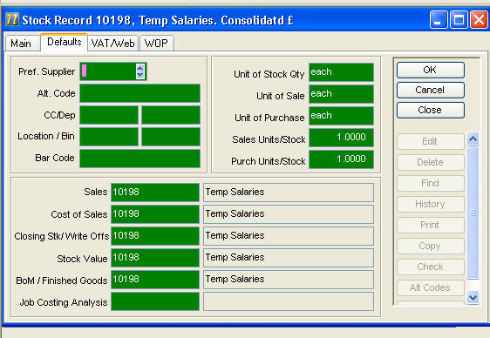

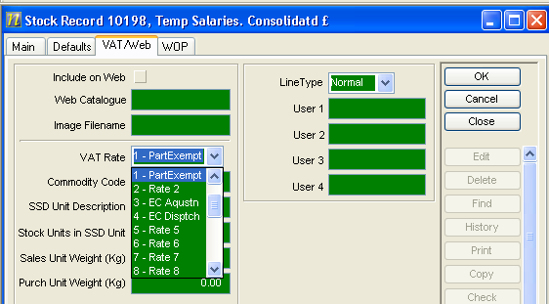

VAT Rates
Within the Exchequer VAT Rates setup, a VAT Code is allocated for Part Exempt transactions and is set to the standard rate of 17.50%.
A special VAT Code, Y, is also allocated to hold the Percentage Proportion Allowed that is to be applied to the Standard Rate of VAT for Partial Exempt transactions. This value will be set at the start of each quarter. This VAT Code will not actually be used against any transaction – it is simply used as a convenient way of storing the Percentage Proportion Allowed value within Exchequer.

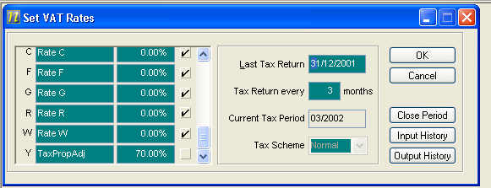
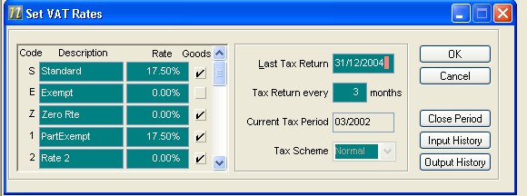

Using this structure, the allowed and disallowed portions of VAT for a quarter may be calculated as follows:
- Allowed = Part Exempt VAT Rate * Tax Prop Adj
= 17.50 * 0.70 = 12.25%
- Disallowed = Part Exempt VAT Rate * (100% – Tax Prop Adj)
= 17.50 * (1 – 0.70) = 5.25%

Purchase Ledger Entry

The VAT Partial Exemption process within the Purchase Ledger is to operate as follows.When a transaction line is entered on the Purchase Ledger, the user keys in the Supply [Stock] Code relating to the type of expense. The system reads the Line Description, the GL Code and the default VAT code form the Stock Record.
Any Supply Codes that are VAT Part Exempt will have the VAT Code set to Part Exempt code. The user may change the VAT code if required.
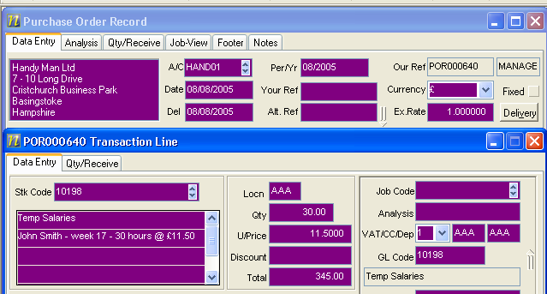
Warning : note that if the default VAT code in the account record is set to Z, A or D then this will over-ride the Supply Code VAT setting.

When the user has finished entering the transaction detail, he/she clicks on the OK button to save the transaction. At this stage, the data entry process has been using standard Exchequer functionality and the transaction should match the Supplier Invoice in terms of the Net Total and VAT Content values.
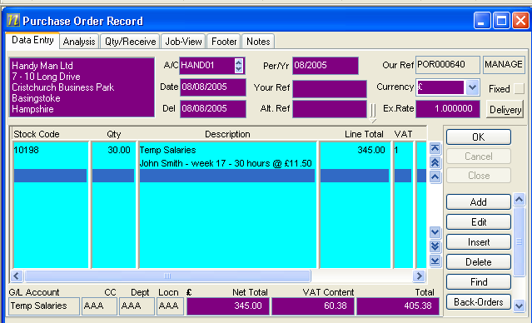

When the OK button is clicked, the VAT Partial Exemption Plug-In is activated. The Plug-In reads each transaction line and, for any line with a VAT Code set to the Partial Exempt VAT Code, will calculate the allowed and disallowed portions of VAT.
To calculate the allowed / disallowed portions of VAT, the Plug-In reads the Percentage Proportion Allowed value held against VAT Code Y (70%) and applies it to the VAT Rate against the transaction line VAT Code (17.50%) . In our example, the allowed portion would be 70% of 17.50% = 12.25% and the disallowed portion would be 30% of 17.50% = 5.25%.
The Plug-In would then
- Recalculate the VAT value against the transaction line based on the allowed percentage:
  - 345.00 x 12.25 % = 42.26
- Create a new VAT Exempt transaction line, using the same supply code as the original line, with a net value based on the disallowed VAT portion percentage applied to the original transaction value:
  - 345.00 x 5.25 % = 18.12 (adjusted for rounding)

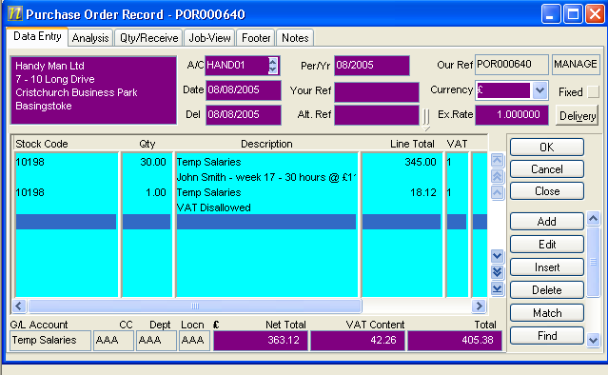

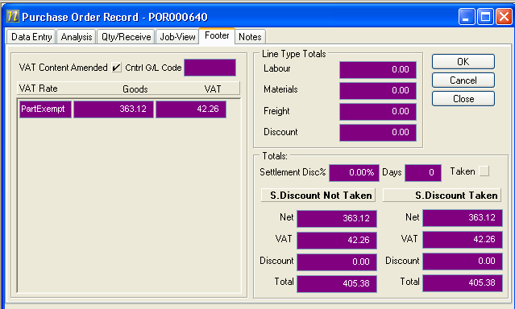

Exchequer Forms

Note that the Exchequer Forms used for printing PINs and PCRs will need to be modified to pick up the original transaction values from the transaction user defined fields.

Nominal Ledger Entry

The Nominal Ledger data entry process for VAT Partial Exempt transactions is similar to the Purchase Ledger Entry other than, as there is no Supply (Stock Code) entry, the user has to manually enter the GL Code and the VAT Code.
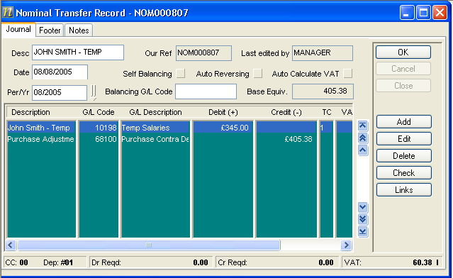
When the user has finished entering the transaction detail, he/she clicks on the OK button to save the transaction. At this stage, the data entry process has been using standard Exchequer functionality and the transaction shows the unmodified Net Total and VAT values.
At this point, the Partial Exempt VAT Plug-In is activated. The Plug-In reads through each transaction line and, for any line with a VAT Code set to the Partial Exempt VAT Code, will calculate the allowed and disallowed portions of VAT. The process is the same as with the Purchase Line entry: the Plug-In uses the allowed VAT % to recalculate the VAT value on the original transaction line and applies the disallowed VAT % to the original net value to calculate the disallowed VAT value that is to be posted as a separate transaction line against the expense code.
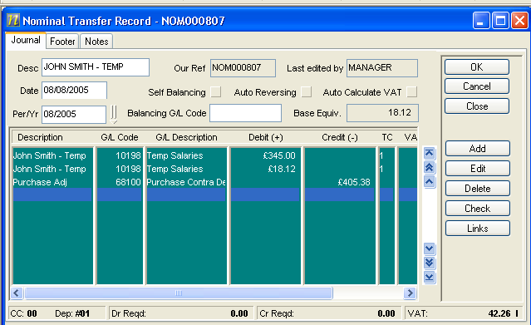
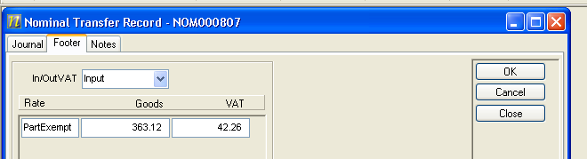

Notes

Editing & Deleting Transaction Lines
The Plug-In will also be activated whenever a Purchase or Nominal Transaction Line is edited or deleted.
If the user changes the value, the VAT code or the GL Code then the Plug-In will adjust the VAT allowed and disallowed values accordingly.
If the user deletes a line, then the Plug-In will check to make sure that there any ‘orphaned’ VAT disallowed lines are also deleted.

VAT Report
Using the methodology described in Sections 3 and 4 above, the standard Exchequer VAT Report should produce the correct analysis values. The basis for this argument is that the adjustment that is being applied to an invoice when a line is partially exempt from VAT is simply dealt with by adding a new line to the invoice being processed as if it were a net value transaction with no VAT and the VAT code carried with it ensures it is summed along with the original net value.

Reporting
When the additional transaction lines are created, a Disallowed VAT reference will be posted to User Defined Field 1. This will allow the Report Writer / ODBC reports to pick up the Disallowed VAT Adjustment values for analysis.
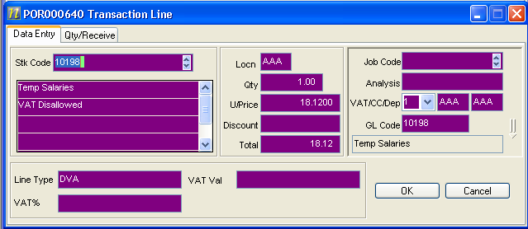

The original VAT % and the calculated VAT value are stored in User Defined Fields in the transaction line.
